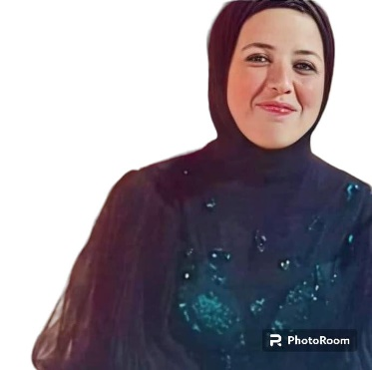 |  |  |  |  | ESRAA ELTANANY  - ARCHITECT AND TAECHING ASSISTANT | CAIRO, EGYPT | israa.ahmed@feng.bu.edu.eg | +201009543200  Dynamic BIM Architect with a proven track record at NAB, enhancing project outcomes through expert use of Revit and AutoCAD. Skilled in client consultation and teamwork, I excel in design development and green building design. My work at SCHEMATIC STUDIO, backed by strong communication skills, significantly improved project delivery through innovative rendering techniques.

Experience
APRIL 2023  TO CURRENTLY TIME |  |  |  | 1BIM Architect (WORKING, SHOPDRAWING), NAB (NEZAR AL-ANGARI CONSULTING BUREAU)  Fifth Settlement, Next To The American University |April 2023 - Current  - Contributed to successful project completion through diligent tracking of revisions and change orders within the BIM environment.  - Optimized building performance by incorporating sustainable design principles into BIM models.  - Enhanced collaboration between architects, engineers, and contractors through consistent use of BIM standards and protocols.
AUG 2020  TO CURRENTLY TIME |  |  |  | Teaching Assistant|FACULTY OF ENGINEERING  BANHA UNIVERSITY - August 2020 - Current  Completed daily reports on attendance and disciplinary performance.  Participated in professional development opportunities to stay current on educational best practices and enhance teaching skills.  Architectural Designer |SCHEMATIC STUDIO  EGYPT, CAIRO, SALAH SALLEM - February 2021 - January 2022  - applied to design planning.  - Coordinated all architectural construction documentation and drawings for each phase of fast-track projects.  Interior and Exterior Finishing Engineer|SWISS CHEM  Dokki, Egypt - January 2022 - April 2022  - Wrote, reviewed and edited technical document in accordance with template requirements.  - Enhanced product performance by conducting thorough failure analysis and recommending improvements.

Education
AUGEST2020 |  |  |  | BACHELOR Architectural Engineering
MAY 2021 |  |  |  | Master's Preliminary Architectural Engineering
Skills |  |  |  |  |  |  | Activities
- Rhino  - Revit expertise  - AutoCAD  - Design development  - Documentation management  - Urban planning  - Green building design  - Teamwork  - Rendering (Revit, rhino, max)  - Interior design  - Drawing preparation  - Client consultation  - Excellent communication |  |  |  |  |  |  | Drawing, running and diving  I love swimming and diving  in an unnatural way, and I  learn this in the club.  I also love running very much,  and I feel an unnatural  release of energy

LANGUAGE

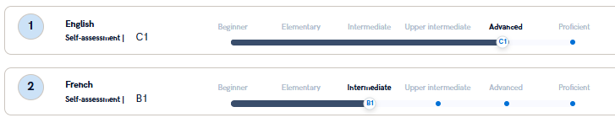
NATIVE LANGUAGE: ARABIC

